

By Trent Smith

This eBook will help you remove or reduce the impact of negative items on a credit report while also teaching how to add positive items to a credit report.
It is also important to note that no one has the legal right to have accurate information removed from their reports. Please note that to charge money for credit repair you need to be licensed. However, it is not against the law to work on your own credit report, even if you are not licensed.

This guide was written with an emphasis on repairing the credit of a customer, though it can be equally applied to repairing your own credit.

TABLE OF CONTENTS
- Understanding a Credit Report
- What Hurts and Helps a Credit Report
- How to Add Unlimited Positive Items to a Credit Report
- Sell to Buyers with Poor Credit
- Step 1 Of the Credit Repair Process
- Step 2 through 5 of the Credit Repair Process

Mailing Addresses for 3 Major Bureaus:

Experian
P.O. Box 2104
Allen, TX 75013-2104
1-888-397-3742

Equifax
P.O. Box 740241
Atlanta, GA 30374-0241
1-800-997-2493
Equifax credit dispute

TransUnion
P.O. Box 1000
Chester, PA 19022
800-916-8800
Trans Union credit report
UNDERSTANDING A CREDIT REPORT
HOW LONG DO ITEMS REMAIN ON A CREDIT REPORT???
Credit Accounts
- Accounts paid as agreed remain for up to 10 years.
- Accounts not paid as agreed remain for 7 years.
Collection Accounts
- Remain for 7 years.
The time periods listed above are measured from the date in your Credit Report shown in the DATE OF LAST ACTIVITY field accompanying the particular credit or collection account.
Courthouse Records Remain for 7 years from date filed except:
- Bankruptcy-Chapters 7 & 11 remain 10 years from DATE FILED.
- Bankruptcy-Chapter 13 non-dismissed or open remain 10 years from DATE FILED.
- Unpaid Tax Liens remain INDEFINITELY.
- Paid Tax Liens remain up to 7 years from the DATE RELEASED.
California State Residents Only: Unpaid Tax Liens remain 10 years from DATE FILED.

REMOVING A FORMER SPOUSE’S INFORMATION FROM YOUR CREDIT REPORT
Please be aware that a divorce decree does not supersede the original contract with the creditor and does not release you from legal responsibility on any accounts. You must contact each creditor individually and seek their legal binding release of your obligation. Only after that release can your credit history be updated accordingly.
If such accounts are still open and available for credit use, then it is prudent to urgently resolve those responsibilities. Once resolved, the creditors should properly update that on your Credit Report during their next reporting cycle to us. If the update has not yet occurred and you have documentation of the release from the creditor, you can provide that material to us via the mail (address listed on your credit report).

HOW BANKRUPTCY AFFECTS A CREDIT REPORT
Because 30% of a credit score is based on outstanding debt and bankruptcy eliminates that debt, we as credit repair companies need to make sure all accounts that were actually included in the bankruptcy reflect that on the credit report. Therefore, in working on someone’s credit who actually filed for bankruptcy, you need a copy of their discharge papers that list all the creditors, so you can make a copy of that for proof to mail to all 3 credit bureaus.

WHAT HELPS AND HURTS A CREDIT SCORE:

WHAT IMMEDIATELY HELPS A CREDIT SCORE
- Pay down all credit card balances to 30% of their high credit. For example, if someone has a credit card with a $1,000 limit, they need to keep that card at or below $300. Paying that balance down from $900 to $300 will immediately add points to their credit score.
- Getting negative items deleted (You do that for them).
- Adding themselves as a joint-applicant on someone’s card (see Adding Positive Items).
- Consolidating their student loans into one payment. It shows all the small accounts as being paid.
- Bankruptcy. Yes, bankruptcy! Thirty Percent (30%) of a credit score is based on the amount of debt you have and a bankruptcy takes that number to $0 in many cases. But, it will be 2 years before they can buy a home with a solid rate, but it does help the actual credit score greatly. Another reason while someone might file bankruptcy is if the debts are large enough to warrant potential judgments. If the amount is $4,000+, it is possible that company might want to get a judgment against them. Bankruptcy prevents that from happening. However, if that debt is more than 1 year old, it is probably that they are not in danger of getting a judgment, as sufficient time has passed to allow for such action.

WHAT IMMEDIATELY HURTS A CREDIT SCORE
- Buying a new pick-up, house, getting a credit card. After time, these will help them, but not for at least 6 months or so.
- Inquiries hurt a credit score 3-4 points each time their credit is pulled. The negative affect decreases over time. Inquiries remain on your credit for 2 years & cannot be removed by any credit repair process.
- Recent late payments, especially 60 or 90 day lates. Your persons need to keep paying their bills while you do credit repair.

HOW TO ADD UNLIMITED POSITIVE ITEMS TO A CREDIT REPORT

Add themselves as a joint-applicant to a Friend or Relative’s Credit Card
The person may add themselves as a join-applicant on someone's credit card who has excellent pay history and keeps the balance relatively low (not maxing it out, or ideally keeping it at 30% of the credit limit.). The ENTIRE paying history for that card will be added to your report(s). Get on 3-way with the credit card company and have them add you, not as a "buyer" but as a "Joint applicant” or “Co-Applicant”. (This will result in a drastic and IMMEDIATE INCREASE IN SCORE)

ITEMS THAT WILL CAUSE IMMEDIATE DECLINE IN SCORE, BUT AFTER 6 MONTHS OR SO, THEY WILL BE GREATLY HELPED BY DOING THESE THINGS. NOT GOOD IF THEY ARE TRYING TO GET A HOUSE IN THE NEXT 6 MONTHS. VERY GOOD FOR ESTABLISHING LONG-TERM CREDIT.

- Get secured installment loans. Wells Fargo, Bank of America (See attached Article)
- Get secured credit cards - Orchard Bank (www.orchardbank.com). Bank of America also has one. There are others as well. Wells Fargo. The person will deposit approximately $300 into an online savings account with the credit card provider. The person will get this money back when they cancel the credit card. If the person does not pay his or her bill, the credit card company will seize the $300 to pay the outstanding balance. The person needs to keep this credit card at approximately a $75 balance on a $300 credit limit card.
- Look up "Loans" in the phone book & call around. Find one that reports to all 3 bureaus and get a few small loans from them & pay it back in < 3 months. You can add many positive items by doing this.
- Rent Reporting → Several companies report rent to the credit bureaus.
Adding Positive Items to a Credit Report, by Trent Smith

Well, you know how the saying goes, and I’ve heard many of my clients say it over and over again. How am I supposed to re-build my credit if I can even get a loan because of my bad credit?? If you find yourself in this situation, you’ll be happy to know there are several free or inexpensive options available to you.

Although I am in the business of deleting negative items from people’s credit reports, I have also obtained knowledge of adding positive items to a credit report. The first method is one of the oldest tricks in the book, and I learned it before I ever began credit repair!

Secured Bank Loans (12-month Plan): If you have some extra cash lying around, why not use that to build yourself a solid credit history? Here’s how you do it: Step One is to go to a bank and open up a 6 or 12 month CD. Step Two is to get a loan against that CD for the amount of the CD you have secured. Your approval is guaranteed at almost all banks, even Wells Fargo. Step Three is to put that loan money into a checking account and have the money from the checking account go to pay the loan every month setup on auto-pay. After the 6 or 12 months, the loan will be paid and you can get your CD back. All it costs you is a little interest, but you have solidified your credit. I did this with 3 banks over 1 year and increased my score by 90 points.

Becoming a Joint-Applicant (Immediate Results): If you’re able to do this, it can be one of the best things you ever did for your credit! What you need is a brother, sister, close friend, or other family member to allow you to add yourself as a “Co-Applicant” or “Joint-Applicant” on one or more of their credit cards. You don’t even have to get a card in the mail. All that will happen is that Credit Card Company will report THE ENTIRE pay history of that credit card on BOTH of your accounts. That’s right, if they’ve had the card for 10 years, all of that will show up on your report. So, it’s important that this is someone you trust to make the payments. This method involves no risk to the current holder of the card and none of your credit history will show on their reports. Just get on a 3-way call with you, your friend, and the credit card company and tell them you want to do this.

Have your Rent Report to your Credit. The company I recommend for this is MakeRentCount.com. They can report the rent you are currently paying your landlord to your credit reports for a small fee. And, because the dollar amount of rent is usually fairly high, that makes it even better for your credit score.

Get a secured credit Card: For this, I highly recommend OrchardBank.com. They report to all the bureaus and guarantee approval. If your credit is really bad, they will require you to put up $300 into a Savings account to get a credit card with a $300 limit. When you close the account you get the original $300 back, or you may request it after establishing a good pay history. Keep the balance under 50% at all times and this will greatly help your credit after 6-12 months

Sell to Home-Buyers who have Poor Credit

What many real estate companies are starting to do is find the buyer, THEN match that buyer with a house they have for sale. This can be an excellent strategy. Many investors would rather deal with people that are already pre-qualified for a loan, but we don't live in a perfect world, and sometimes we have to employ other tactics to get a buyer for our homes.
Getting lists of buyers with bad credit can be doing fairly quickly, by placing ads listing the house/houses for sale, along with "Bad Credit OK." Sometimes, these buyers will have better credit than they thought and will already be qualified for a loan. Some mortgage companies will finance people with as low as a 560 credit score, although 580 is a more common bottom number.
If the person's credit score still falls under the mark, I recommend signing them up for credit repair to remove inaccuracies on their report, and working on their credit so that they can get into the home you have for sale.
Many people outsource the credit repair to other companies, but there are a couple problems with this. You often lose touch with the client and they don't return, and the credit repair company can often over-charge and not do the work as promised.
STEP 1 OF THE CREDIT REPAIR PROCESS: INITIAL DISPUTES OF INNACURATE NEGATIVE INFORMATION

THERE ARE 2 WAYS TO DO STEP 1!
Online or by Mail. Either way, it takes just 30-40 days for the person to get new credit reports at their home address from Experian, Trans Union, and Equifax listing the negative accounts that have been deleted.

IF YOU HAVE AN UPDATED CREDIT REPORT:
DISPUTE NEGATIVE ITEMS WITH TRANSUNION
- Go to http://www.transunion.com
- Click “Dispute an item on your credit report.” On the right-hand side of the page
- Click “Dispute Online”
- Go to the bottom of the page and click below where it says, “If you did not receive your credit report directly from TransUnion ... and click
- You will see the following page:
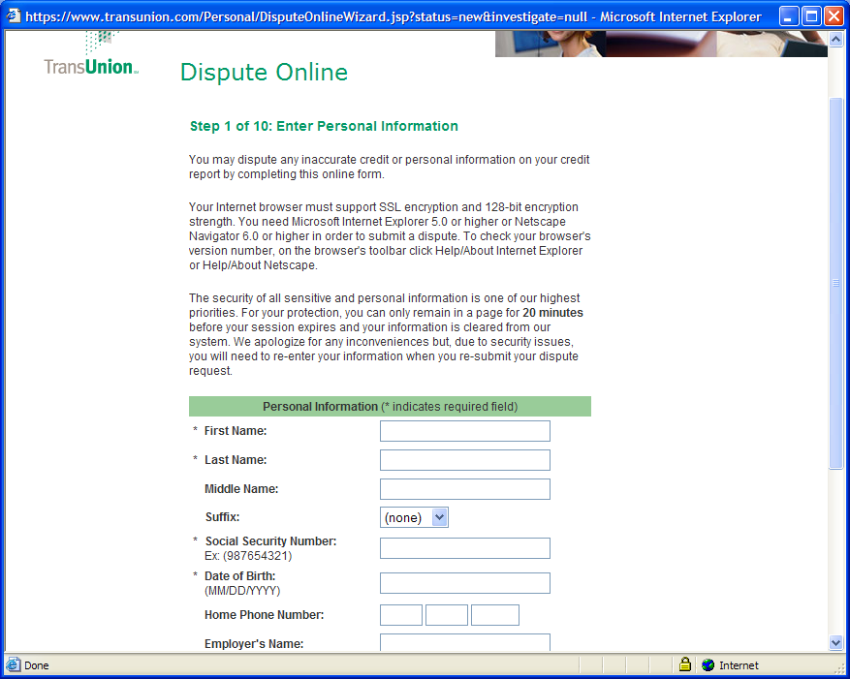
- Fill in the appropriate information and click, NEXT
- On the next page, enter the current address of the person who’s credit you are working on. This is where the results of the investigation will be sent back to.
- You will now be directed to a page asking for the previous address. You can skip this page without entering a previous address.
- Now, it asks for a file number (if applicable). Skip this page as well.
- Click Next on the Personal Information Page
- Now, click . Enter the name and account number of the item.
- To request the account be removed, click “Not my Account”
- To request the removal of a late payment, click “I have never paid late”, and so on.
- After adding all the disputes, click Next and submit the Disputes.
DISPUTE NEGATIVE ITEMS WITH EQUIFAX
- Go to http://www.equifax.com
- Click “Online Dispute” at the top of the page
- Enter the zip code of the person for whose credit you are repairing and click next.
- Because you are using a credit report other than one obtained directly from Equifax, Click, the top link that says, “If you do not have a confirmation number, click here to start your investigation”
- Enter the required information, along with the disputes on the following page: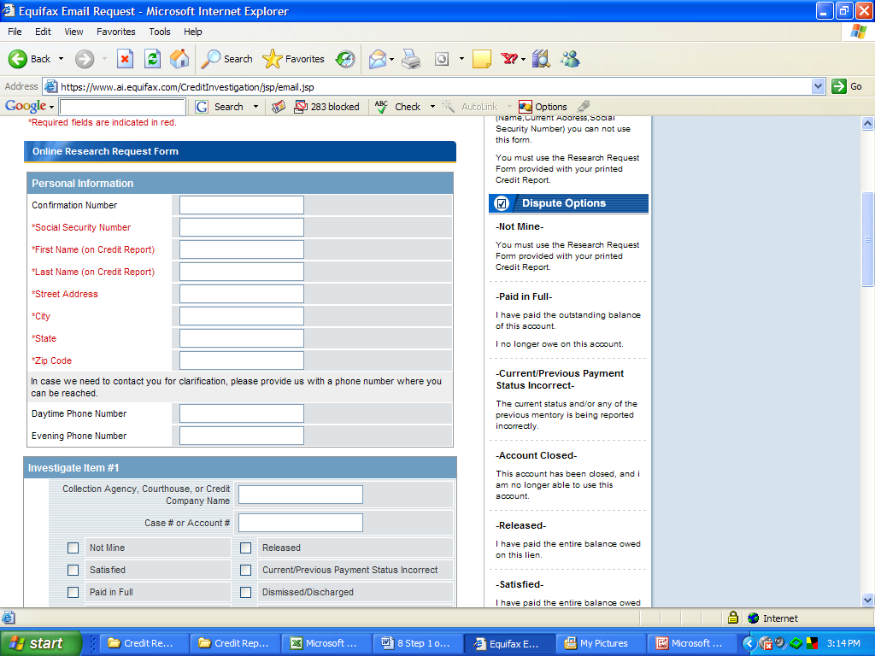
ANNUALCREDITREPORT.COM
* Important Note: You are only allowed to gain Access to AnnualCreditReport.com ONCE per year. There are some instances when the 30-40 day time period for the person receiving their results in the mail has passed and you want to be able to repull their credit report to see what changes have taken effect. Therefore, you want to try and avoid pulling the Annual Credit Report until at least 45 days after you have begun work.

DISPUTE NEGATIVE ITEMS WITH EXPERIAN
- With Experian, you cannot dispute negative information online unless you have a CONFIRMATION NUMBER! They do this so they can sell more credit reports for $9.50 each. However, you everyone is entitled to a free annual credit report from http://www.annualcreditreport.com. Therefore, you can go to this website, fill out the necessary information, and obtain a copy of the persons Experian Credit Report, and dispute the negative information that way. However, I advise doing the Experian Step by mail for the initial disputes (you need the identification documents listed above) so that you will have access to pull their NEW Experian report at a later time.
- Go to http://www.annualcreditreport.com, and select the person’s State. You will see the following page. Enter their information and click, Next. 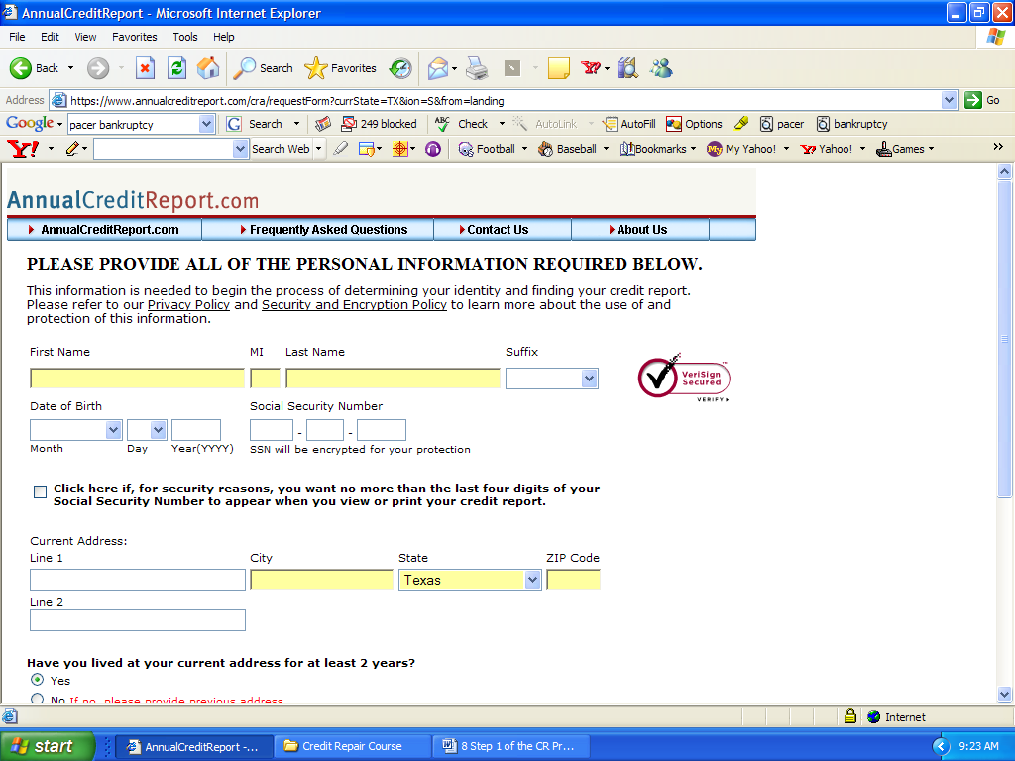
- You will have the option to get copies of 1, 2, or all 3 of the person’s credit reports. In this case, we will pull only the Experian Credit Report. Select “Experian”, then click Next.
- You will be asked a series of 2-4 questions to confirm the person’s identity. Typical questions include, what finance company are you using to finance the Auto Loan in or account November of 2003. You can answer these questions using the credit report that you currently have. If there is any question, you will need to call the person to verify the correct answers. If you answer any questions incorrectly, you will be logged out, and will need to SUBMIT THE EXPERIAN DISPUTES BY POSTAL MAIL.

IF YOU DON’T HAVE A CREDIT REPORT:

- Mail off the ANNUALCREDITREPORT.COM request form (they will get their reports in the mail in about 10 days OR
- You will need their assistance in getting their reports immediately from annualcreditreport.com.
- In obtaining free copies of their reports, Trans Union, Equifax, and Experian will each ask a series of questions in order for you to obtain the reports.
- These questions, especially Trans Union, often ask for specific account numbers on Installment and Revolving accounts.
- If the person cannot answer these questions, you will need to mail-off a request for their credit reports.
- Once they receive the credit reports in the mail, they need to fax or mail them to you so you can continue with Step 1. Once you receive these you will have a confirmation number so you can do the Experian Credit Disputes online. Although you do not need a confirmation number to do Trans Union and Equifax online, you can still use the confirmation number to make the dispute process easier and do those online, too.

** NEW CREDIT SCORE AFTER INITIAL DISPUTES
The persons will often want to know their new credit score after they get letters back in 30-40 days telling them many items have been deleted. In order for them to get their new scores (if you haven’t already pulled a credit report from annualcreditreport.com), have them visit AnnualCreditReport.com and pull their scores. It will cost them $5-$10 for each report, so they should be prepared for that. Many times, however, if they are dealing with a mortgage company, have them return there to see their new scores.

METHOD #2 – SEND LETTERS W/ COPY OF SOCIAL SECURITY & ADDRESS VERIFICATION –
- The address on the Driver’s License or other form of address verification will be where the letters will be sent. If you were not able to collect any or all of these items, you will need to do all of this online, or instead of using the Driver’s License, include an alternative source of address verification, as referenced above If they get their mail forwarded from this address to another address, you can use this address. Still, sometimes they will not get all the letters in the mail (they get lost in the mail), but that does not mean many things have not been deleted. If it’s been 40+ days and they haven’t gotten anything, items have still been deleted, almost guaranteed. They just haven’t gotten the letters. If they do not have a SS card available this, you need to include copies of 2 other proofs of SS, such as Old W-2’s or any other official documents.
- Remember, you are acting as an agent for the person whose credit you are repairing. The letter needs to come from them and be signed with their name (You do this for them: You are granted power of attorney in the contract).

SEE INITIAL DISPUTE LETTERS ON THE FOLLOWING PAGES

OTHER IMPORTANT TOPICS

Disputing the Collections First
This is something only the top credit repair companies will do, and should do in certain cases. The primary reason for this is as follows: There are some instances in which, “If the person didn’t have bad credit they wouldn’t have any credit at all.” Therefore, deleting too many items can jeopardize their score from going from, say a 540 to an N/A, or “Not Available.” In most of these cases, the only thing keeping their score from being an N/A is having a charged-off credit card or repossessed vehicle. Now, although this may actually look very bad on their credit report, they may have paid on the car for 30 months before it was repossessed. If this is the case and they have little or no other positive trade-lines, this account is likely to actually be helping their credit score. Therefore, we want to leave that account alone for the time being and just go after the collection accounts, because there is no chance at all that one of these accounts is actually helping their score. If after deleting many of the collections, the score is still not sufficient, it is time to go after the repossession or charged off credit cards.

Child Support
At least in Texas, Child support is one of the easier items to get removed from a credit report, or get the late payments removed. This is an excellent opportunity to turn an otherwise very negative account (Only if they have been late on the account) into a very positive account with good pay history. Therefore, we get the credit bureaus to remove the lates, not completely remove the account.

Rapid Rescore
This is something that will be done by the mortgage companies with the Credit Report Company (not the credit bureaus) if the person has documentation releasing them from a debt or late payment on their credit report. If they have this proof, it is your responsibility to mail this documentation into the credit bureaus so that it will be updated correctly with them, as well. It is important to note that the mortgage company getting the report updated with the Credit Report Company (Kroll, Factual Data, MILA, Alliance, & many others), does not affect their actual credit file with Experian, Trans Union, and Equifax. As noted above, you will need to mail the documentation in for them to get that corrected.

Date of Last Activity ( Older than 7 years??)
Another arsenal in the playbook for getting negative items deleted in verifying the date of last activity for many of the accounts. The date of last activity should reflect the DATE OF LAST PAYMENT. Therefore, if a person opened a credit card in 1995, but they stopped paying in 1999, that particular item may remain on the credit report for seven years (beginning in 1997 when they made their last payment). Therefore, it has to come off in 2004. Now, not only does the original account have to come off in 2004, but also does the COLLECTION COMPANY line item as well (Most credit card companies send an item to a collection company after 120 day). Many of these collection companies will either not report the date of last activity or have incorrect information pertaining to the date of last activity. Both the collection company and the original creditor line items must be removed.

One Credit Card Becomes 2 negative items
By rule of the credit bureaus, they may both show up on a credit report, so we use all of our credit repair methods to remove both of the. The credit card account, by the way, will show a $0 balance and the collection account will show the existing balance. Work on these just as you do all the other accounts, but it cannot be disputed as a “duplicate account.”

STEPS 2-5 OF THE CREDIT REPAIR PROCESS

Use the Letters in the accompanying ZIP File to Do Steps 2 through 5

